**NAME: SUHRID DAS**

**EE556 Course Project:**

**Devising Gradient-free Test-Time Evasion Attacks on MNIST Dataset**

**PROJECT OVERVIEW:**

The course folder consists of a network trained on the MNIST dataset. The objective is to implement gradient-free test time evasion targeted attacks to attack each test sample and misclassify it to a randomly chosen target class.

I have implemented 2 different gradient-free attacks by using the Zeroth Order Stochastic coordinate descent with coordinate-wise ADAM optimization and Zeroth Order Stochastic coordinate descent with coordinate-wise Newton’s Method respectively. Due to limited computational infrastructure, I have used my codes to perturb 700 and 500 images from the dataset for the two algorithms separately. I have computed and stored the attack success rate and the average number of classifier queries required to achieve a successful attack.

I have ensured that the attacks on the images are human-imperceptible. Finally, I have collected all the data to report the altered performance of the classifier on being fed both original and adversarial images. I have mentioned a simple adversary detection procedure and have plotted the ROC AUC curve by varying the true detection rate versus the false positive rate and by changing the detection threshold.

**IMPLEMENTATION**:

*ARCHITECTURE*:

The main file which is responsible for calling all the functions is named: proj_main.m. The variable ‘classLabels’ has been created to initialize the 10 original types of data which are in this case numbers from ‘0’ to ‘9’. As mentioned above, I have perturbed a limited number of images and that number is specified by the variable: ‘numTestIms’. The number of successfully perturbed images has been stored in the variable: ‘successTrials’. The final perturbed images are stored in ‘imsAdversarial’. The variable ‘tgtLabels’ stores the randomized adversarial target label for each image that has been perturbed and ‘finalPred’ stores the soft labels for the adversarial images passed through the classifier.

For the number of images decided to be perturbed, we store the true label in ‘groundtruthLabel’ and chose a random target label to which it will be misclassified by the classifier. The choice of the perturbed label is any one of the labels other than the true label.

*The ADAM Optimization*:

The function takes the following as its inputs:

The Original Image

The Adversarial Target Label

The Network

I refer to the paper given by professor **ZOO: Zeroth Order Optimization Based Black-box Attacks to Deep Neural Networks without Training Substitute Models** to implement the ADAM optimization algorithm.

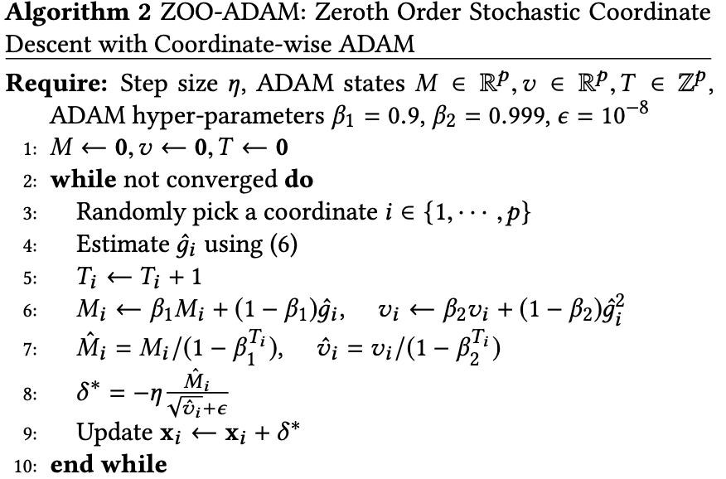

All the initializations required for implementing ADAM have been done as follows:

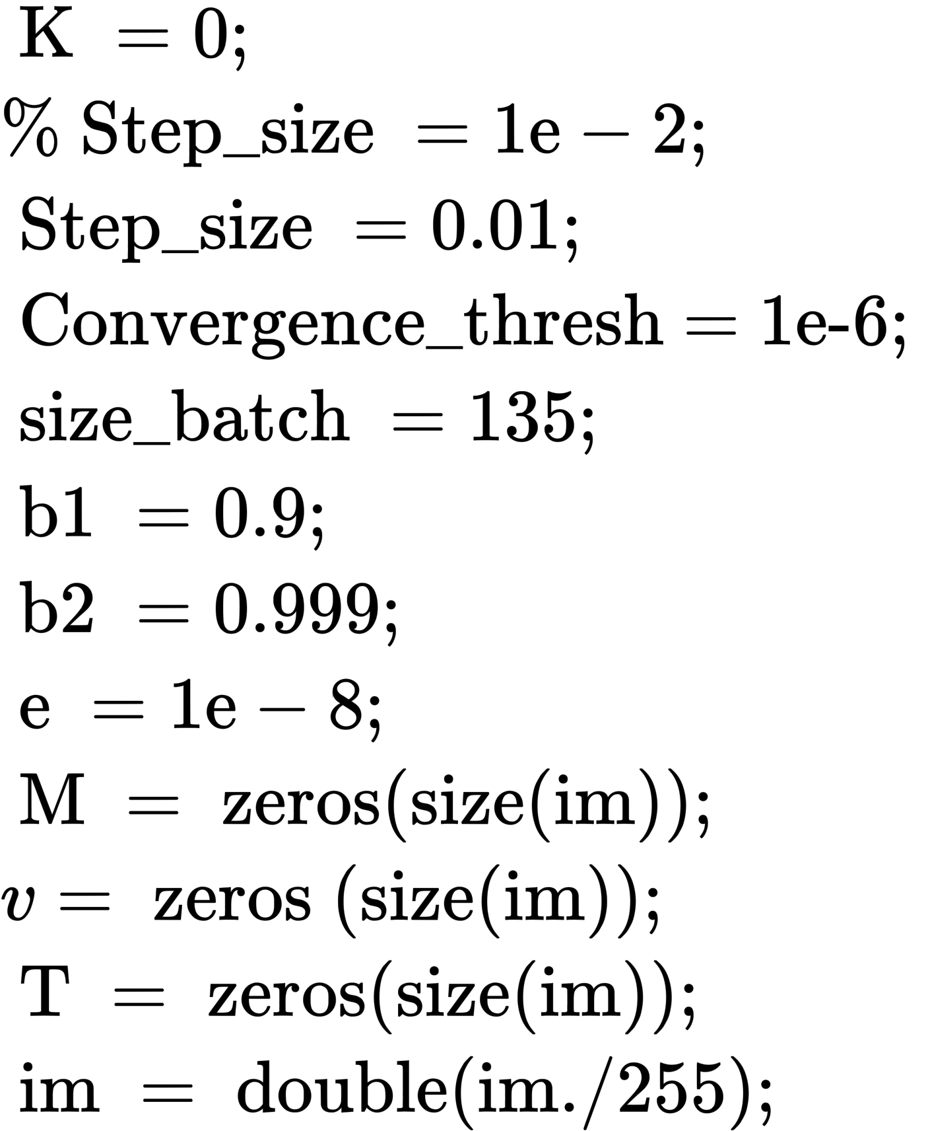

After this, the algorithm is run several times until the Convergence Criteria are achieved. The convergence criteria are purely heuristical and I have tried different sets of values to check which works best. I have also introduced a variable called COUNTER whose value has been set to 9 which makes sure that the perturbations on each image have been done at most 9 times. The batch size refers to the number of randomly selected pixels to be perturbed in each image. This value can also be changed. All these heuristics have been set such that the perturbations in any of the images are big enough to make the classifier misclassify it but at the same time implement the changes in the original image so that it is not human perceptible.

*The Newton Method*:

Similar to the ADAM optimization, this function takes the following as the input parameters:

1. The Original Image
2. The Adversarial Target Label
3. The Network

This algorithm essentially does the same thing as ADAM but with a different procedure. The coding for the algorithm has been done using the pseudo-code given in the paper mentioned above.

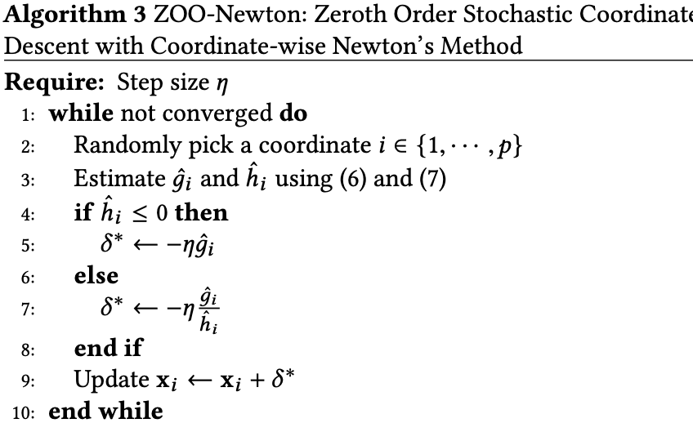

Here again, the images are perturbed till the convergence criteria are achieved.

The initializations have been done as follows:

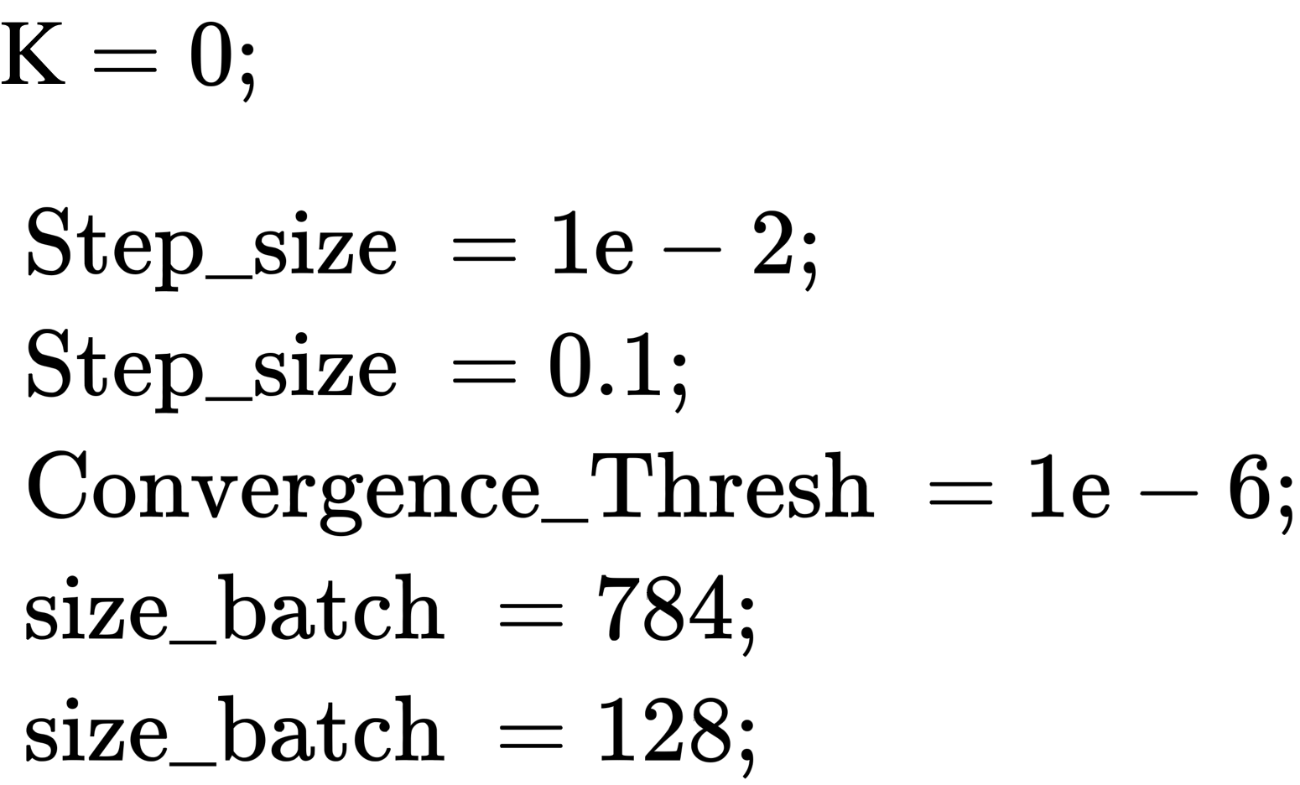

Additionally, in this algorithm, we also compute the hessian and set limits to its value to render it mathematically feasible.

*Loss Functions*:

Both optimization methods optimize the loss function which is calculated using the following formula:



The loss function is updated using:

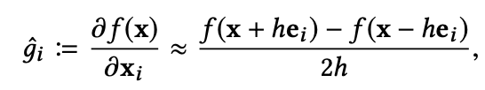

We can clearly observe that the loss function is calculated using the simple definition of the derivative. In the code, I have initialized the small step as ‘h’ and set a very small value to it for the derivative to be calculated accurately.

For each image to be perturbed, until the convergence criteria are met I continuously compute the gradient of the loss and update the value of the loss function.

**REQUIREMENTS for the REPORT:**

The report requires us to find the success rate of the adversarial attack, the average number of classifier queries, and the representative attacked image to show whether the attack is perceptible or not.

It is also asked to suggest a simple algorithm to detect the attacks and report the performance.

All of the requirements have been coded down in MATLAB:

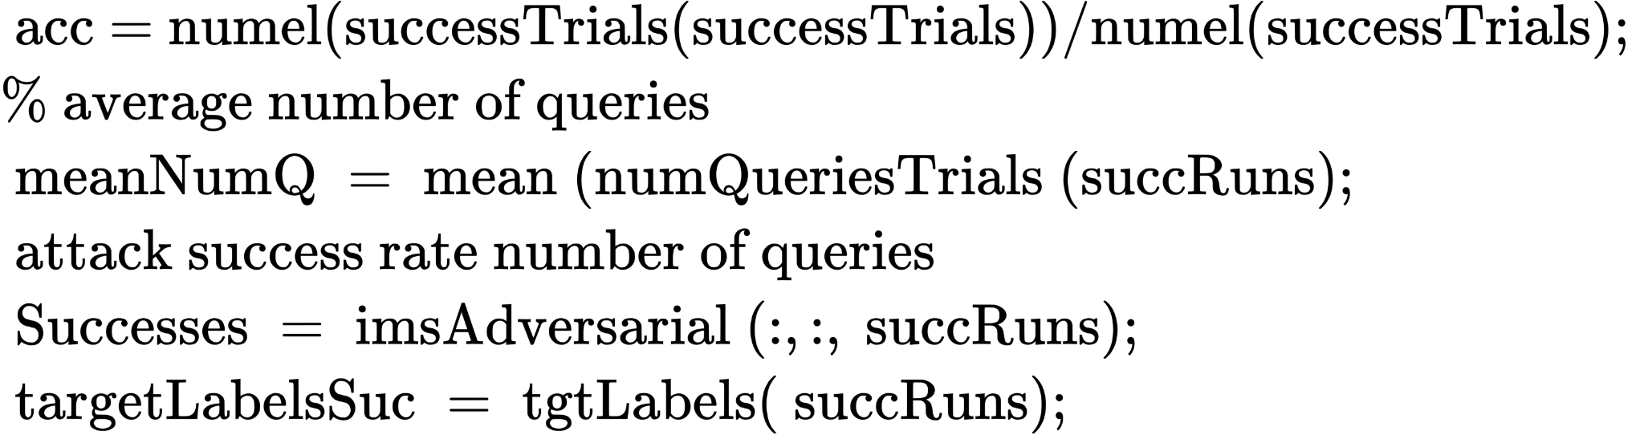

**RESULTS**:

***The ADAM Algorithm***

TEST IMAGES:

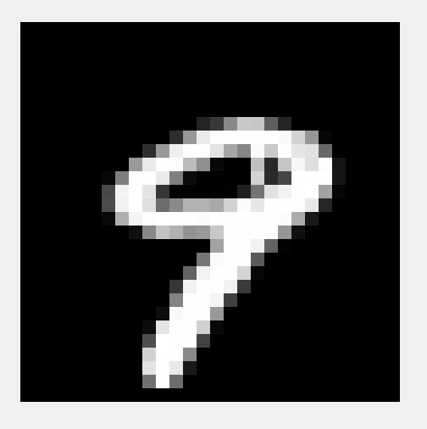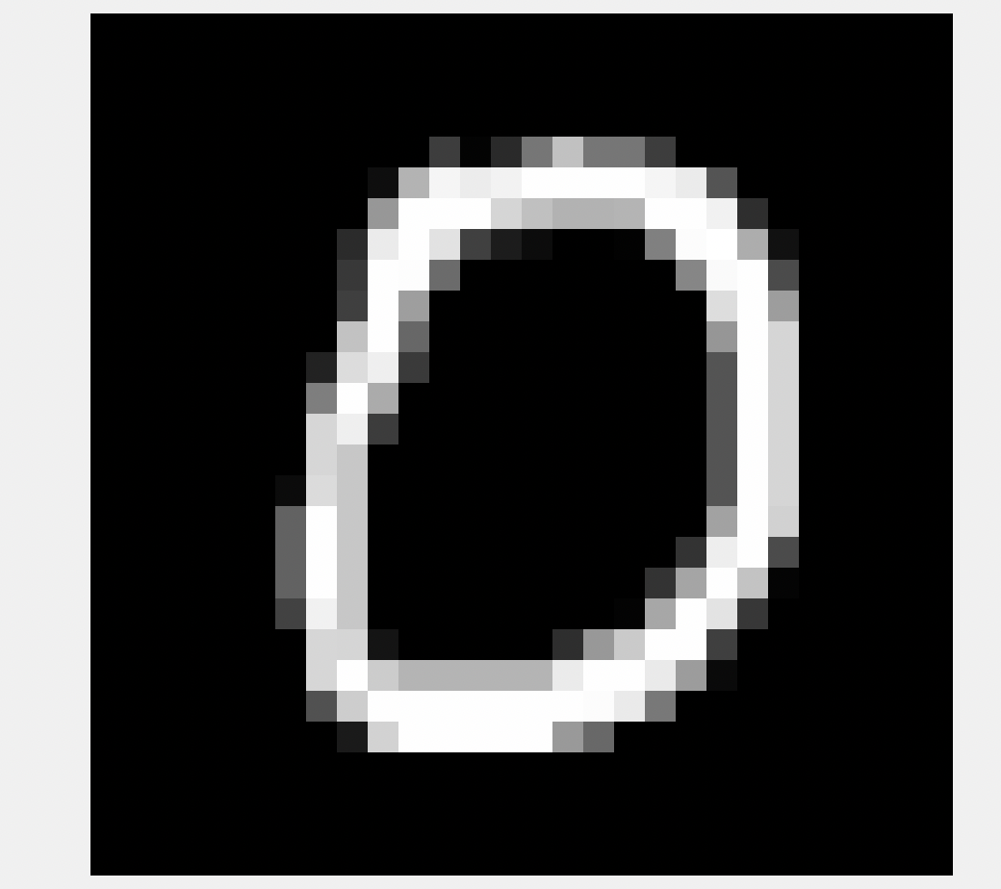 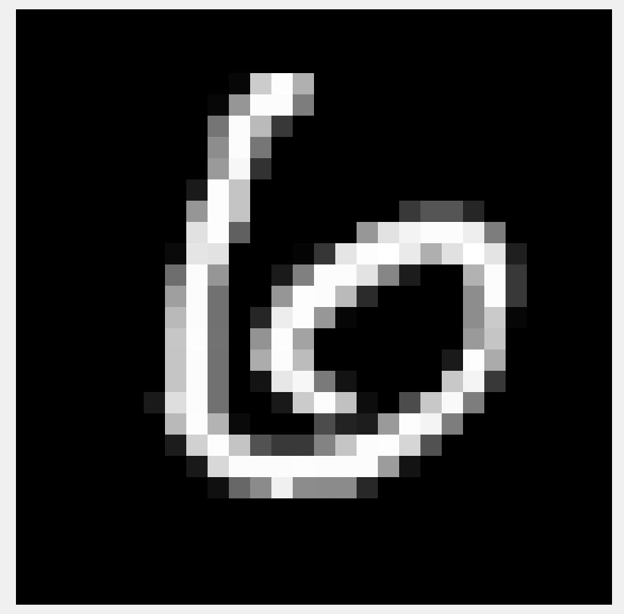 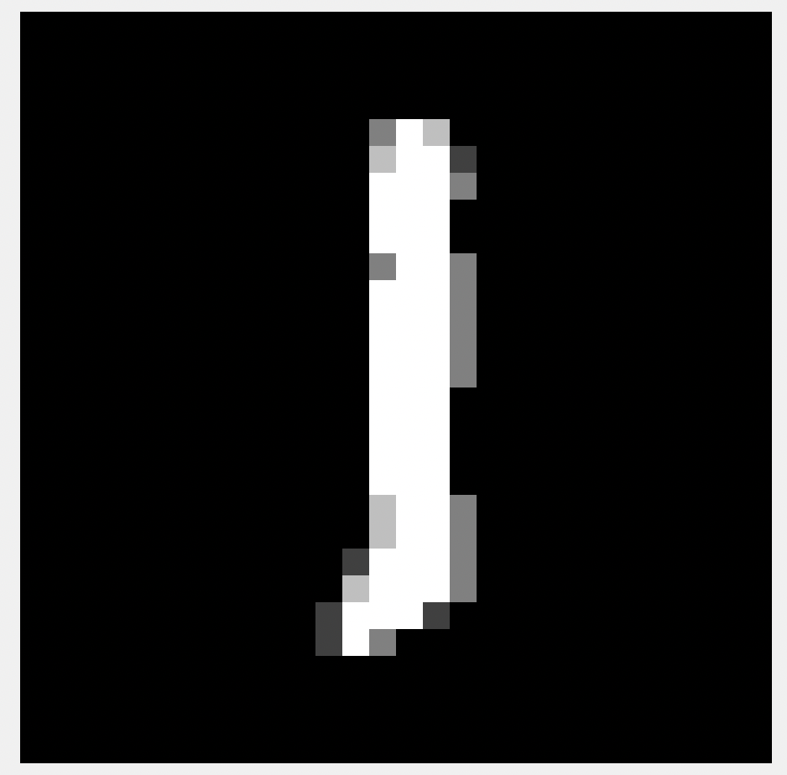 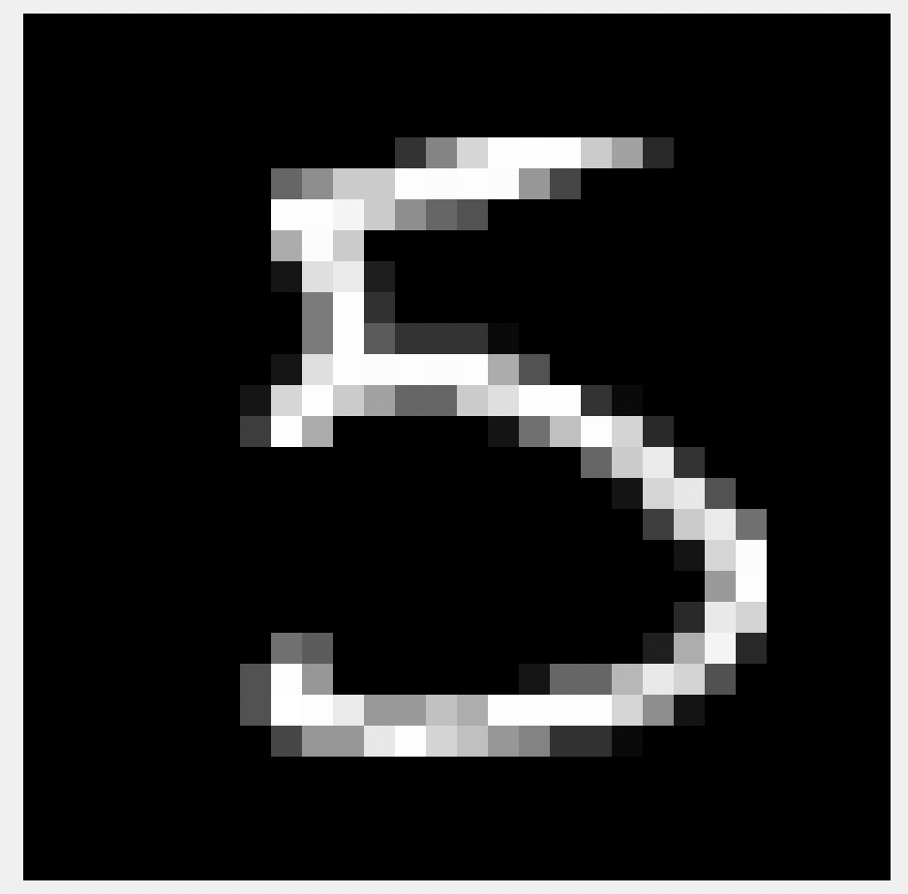

10th Test Image 11th Test Image 12th Test Image 15th Test Image 16th Test Image

Corresponding GROUND TRUTH LABELS:

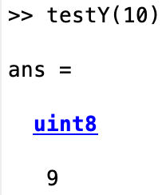 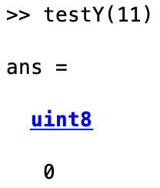 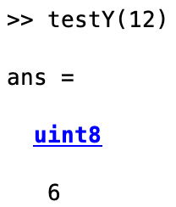 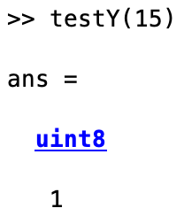 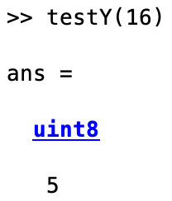

ADVERSARIAL IMAGES on running the ADAM algorithm:

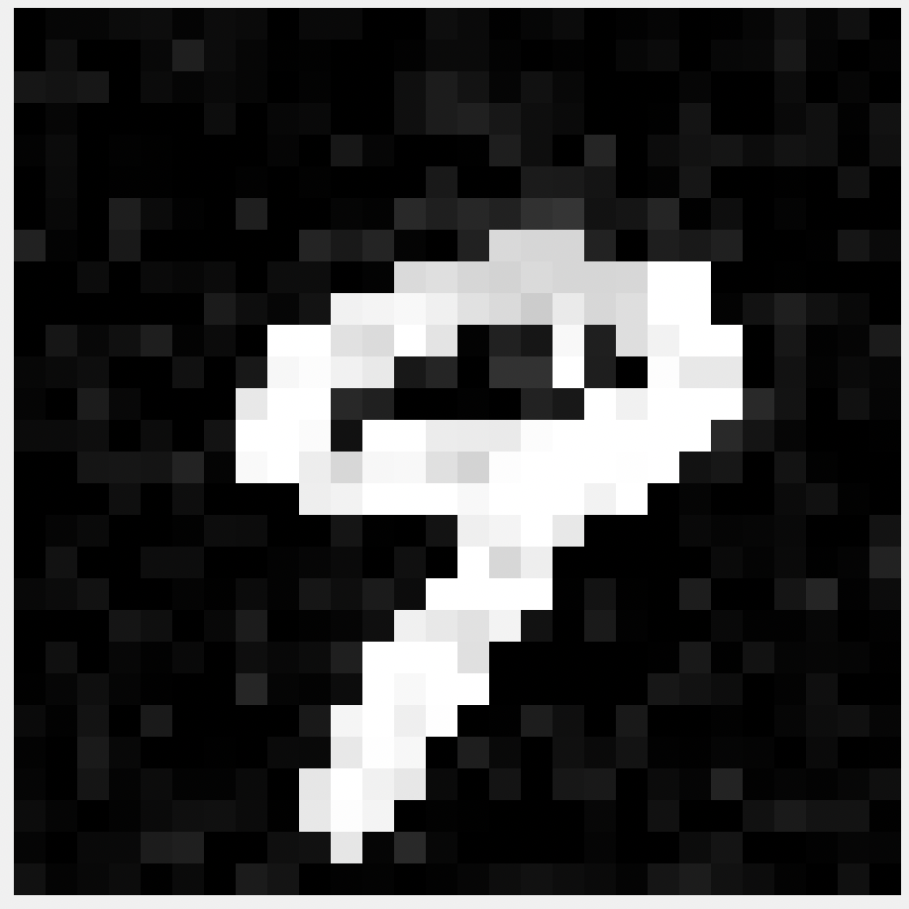 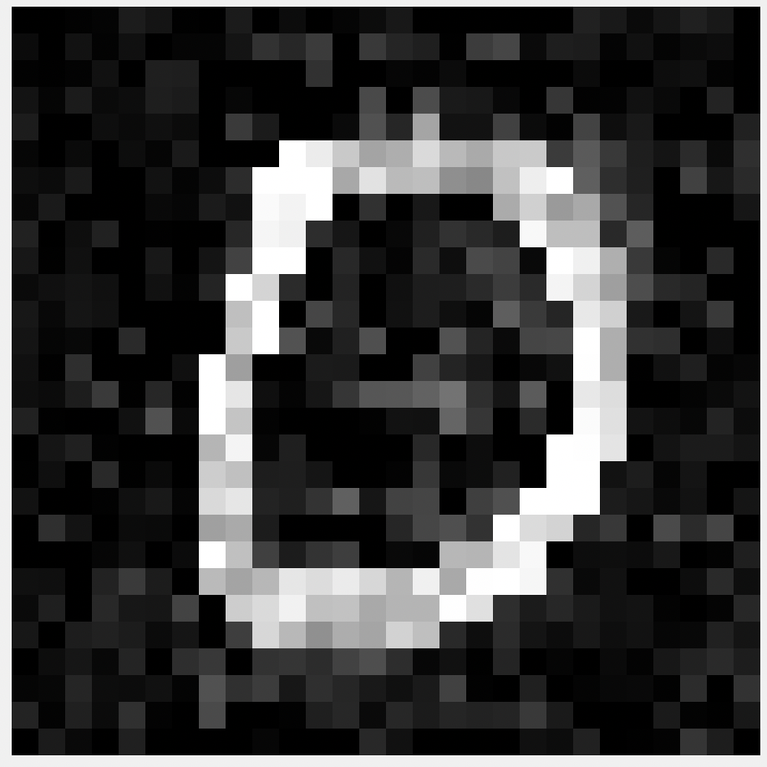 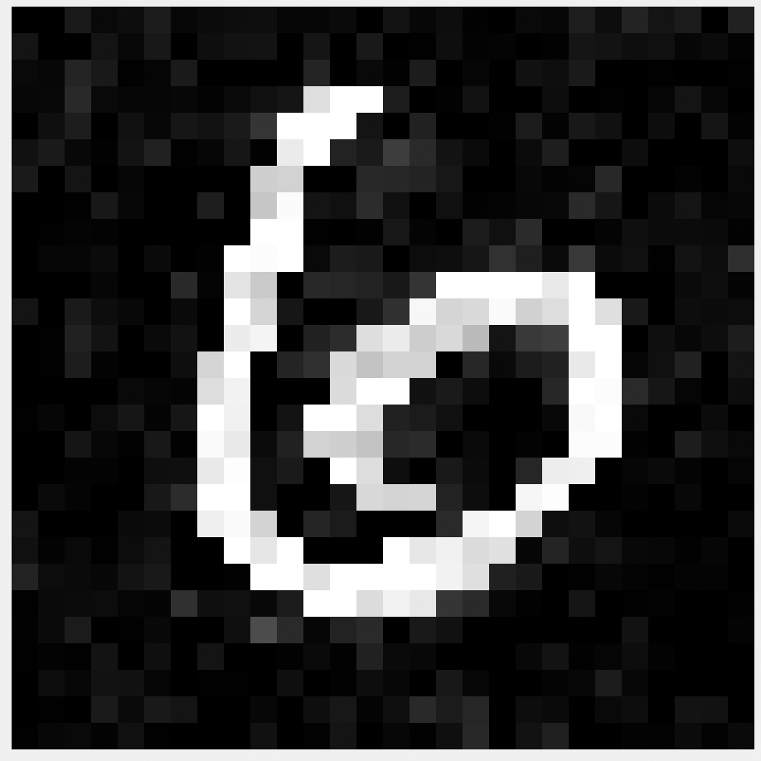 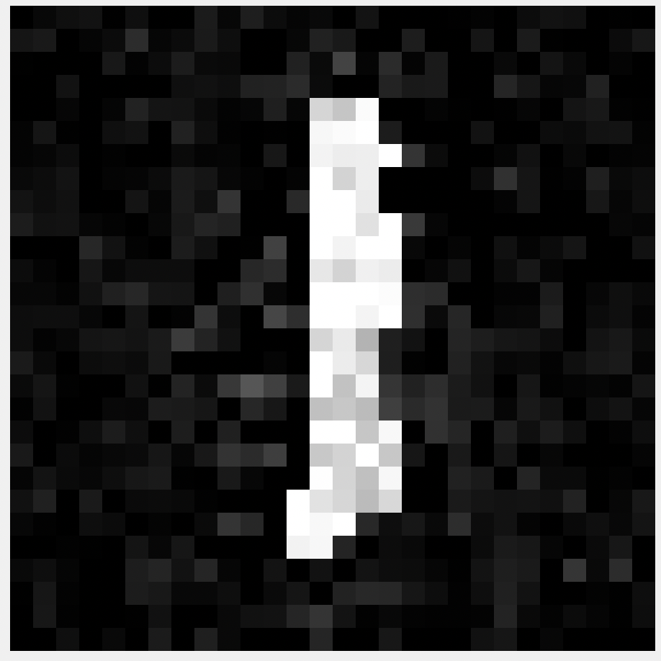 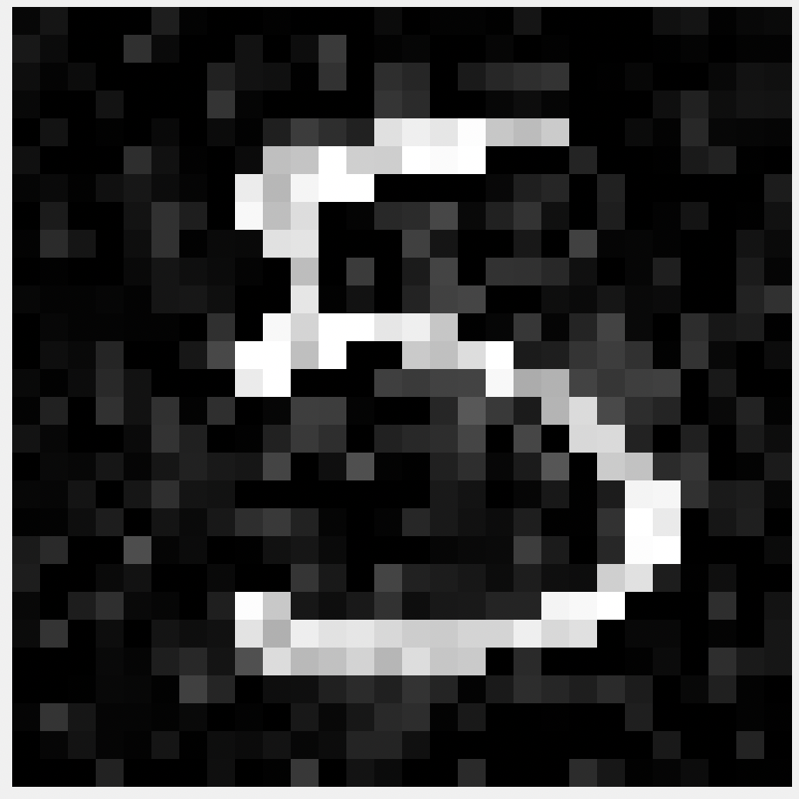

10th Perturbed Image 11th Perturbed Image 12th Perturbed Image 15th Perturbed Image 16th Perturbed Image

Corresponding LABELS as classified by the classifier:

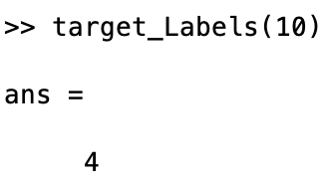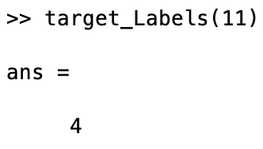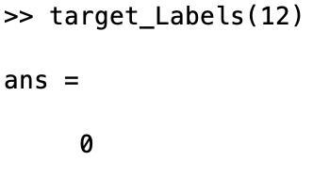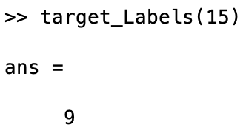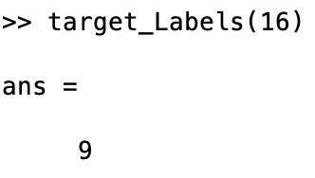

Clearly, all of the given test images have been misclassified into random labels.

The MEAN number of Queries for ADAM:

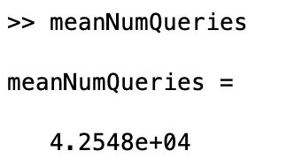

This is the mean number of queries for the NEWTON Method.

Misclassification Accuracy for ADAM:

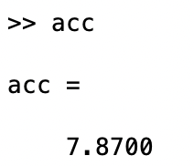

**ROC for ADAM METHOD(For 700 images)**

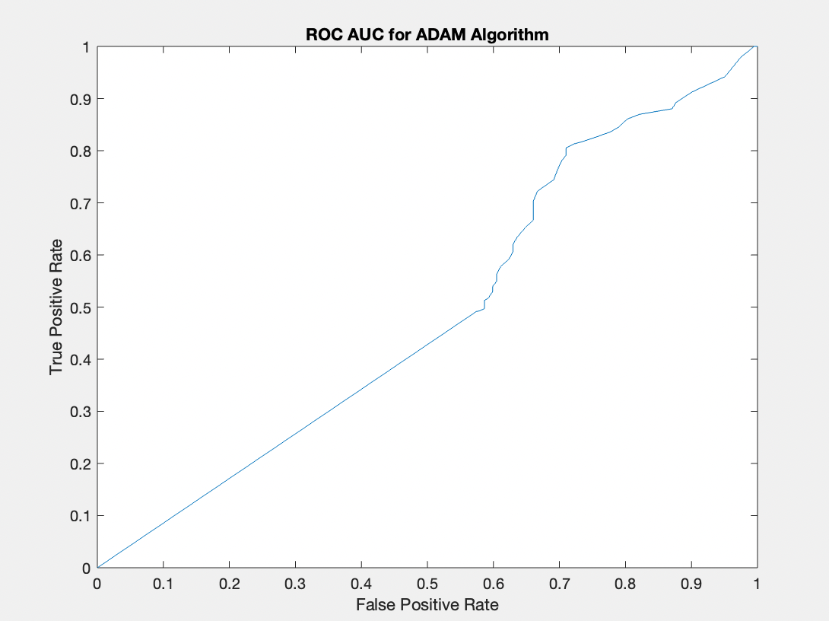

***The NEWTON Algorithm***

TEST IMAGES:

    

10th Test Image 11th Test Image 12th Test Image 15th Test Image 16th Test Image

Corresponding GROUND TRUTH LABELS:

    

ADVERSARIAL IMAGES on running the NEWTON algorithm:

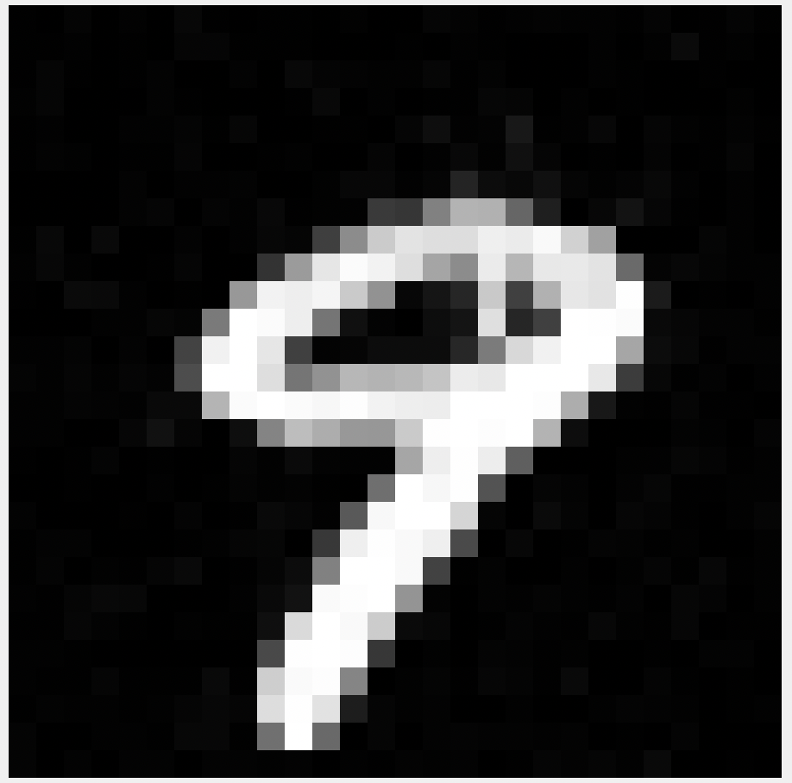 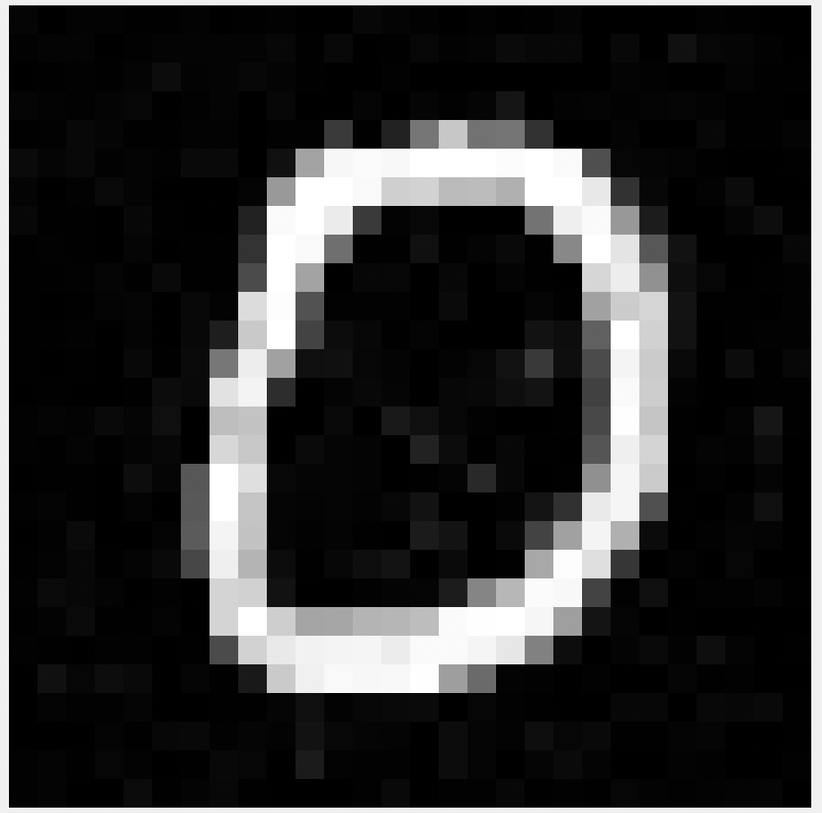 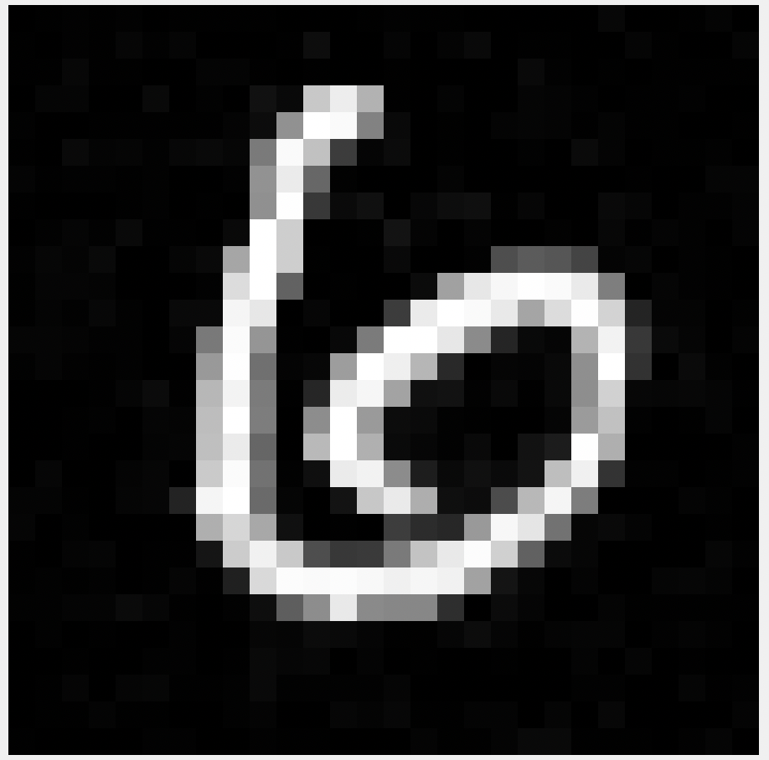 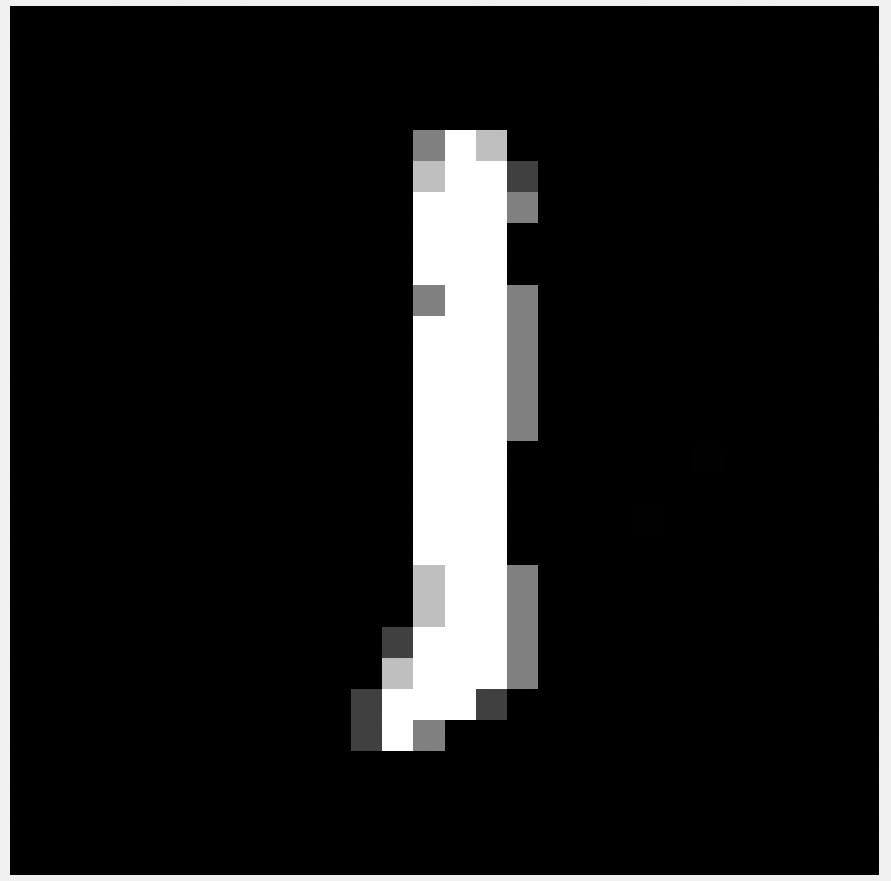 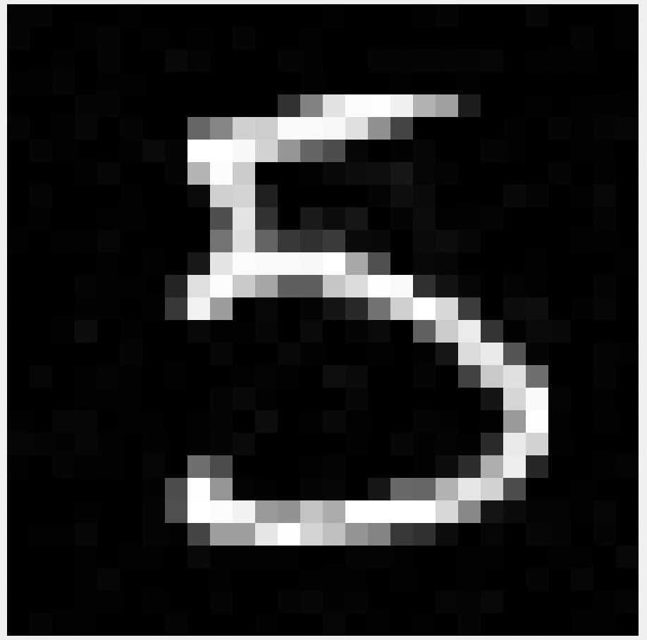

10th Perturbed Image 11th Perturbed Image 12th Perturbed Image 15th Perturbed Image 16th Perturbed Image

Corresponding LABELS as classified by the classifier:

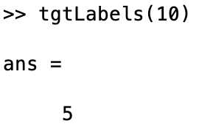 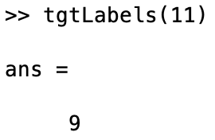 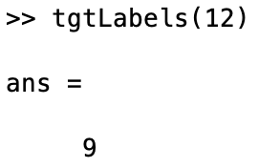 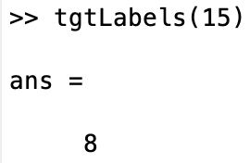 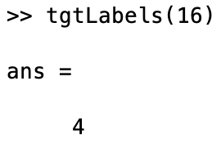

Clearly, all of the given test images have been misclassified into random labels.

The MEAN number of Queries for NEWTON:

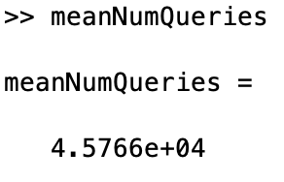

Misclassification Accuracy for NEWTON:

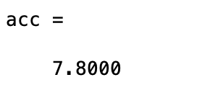

**ROC for NEWTON METHOD(For 500 images)**

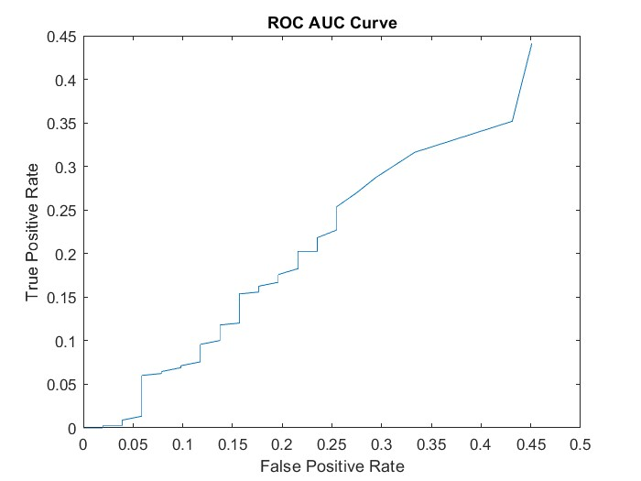

**CODES USED FOR THE PROJECT**

**1) MAIN.m**

clear all; close all;

addpath('utils')

load net;

%% parameters

% Optimization routine to use. Set this to 'ADAM' or 'Newton'

algorithm ="Newton"; %"ADAM";

%% run attack

classLabels = 1:10;

numTestIms = 787; %10000;

successTrials = false(numTestIms, 1);

numQueriesTrials = zeros(size(successTrials));

imsAdversarial = zeros([size(testX,1),size(testX,2), numTestIms]);

tgtLabels = zeros(numTestIms, 1);

finalPred = zeros(numTestIms,10);

for n = 1:numTestIms

testIm = testX(:,:,:,n);

groundtruthLabel = testY(n);

groundtruthLabelIdx = false(1,10);

groundtruthLabelIdx(groundtruthLabel+1)=true;

tgt = datasample(classLabels(~groundtruthLabelIdx),1);

if (strcmp(algorithm, 'ADAM'))

[isSuccess, numQueries, imFinal, finalPred(n,:)] = attack_adam(testIm, tgt, net);

elseif (strcmp(algorithm, 'Newton'))

[isSuccess, numQueries, imFinal, finalPred(n,:)] = attack_newton(testIm, tgt,net);

end

successTrials(n) = isSuccess;

numQueriesTrials(n) = numQueries;

imsAdversarial(:,:,n) = imFinal;

tgtLabels(n) = tgt;

end

%% calculate accuracy and average number of queries

acc = numel(successTrials(successTrials))/numel(successTrials);

meanNumQueries = mean(numQueriesTrials(successTrials));

imsSuccess = imsAdversarial(:,:,successTrials);

tgtLabelsSuccess = tgtLabels(successTrials);

% save

save(sprintf('%s_results.mat',algorithm),'accuracy', 'meanNumQueries', 'imsSuccess', 'tgtLabelsSuccess');

%%

numTestIms = 787;

finalPredNotAd = predict(net,testX(:,:,:,numTestIms+1:2*numTestIms));

finalPredAll = [finalPred; finalPredNotAd];

tgtLabelsAll = testY(:,787+1:787+2*numTestIms);

tgtLabelsAll(1:numTestIms) = tgtLabels(787+1:787+numTestIms)';

plotROC(finalPredAll,2*numTestIms,testY,tgtLabelsAll);

save(sprintf('%s_ROC_ADAM_results.mat',algorithm), 'numTestIms', 'finalPredAll', 'testY', 'tgtLabelsAll');

**2) ADAM_algo.m**

function [isSuccess, numQueries, imFinal,finalPred] = attack_adam(im, tgt, network)

K = 0;

Step_size = 0.01;

Convergence_thresh = 1e-6;

BATCH_SIZE = 128;

b1 = 0.9;

b2 = 0.999;

e = 1e-8;

%% run ADAM

M = zeros(size(im));

v = zeros(size(im));

T = zeros(size(im));

im = double(im./255);

lossOld = inf;

lossNew = evaluateLoss(im, tgt, KAPPA, network);

numQueries = 0;

isSuccess = false;

counter = 0;

while((abs(lossOld - lossNew) >= CONVERGENCE_THRESH)||counter == 9)

pixelBatch = datasample(1:numel(im), BATCH_SIZE, 'Replace', false);

[grad,~] = evaluateLossGradient(im, pixelBatch, network, KAPPA, tgt) ;

T(pixelBatch) = T(pixelBatch) + 1;

M(pixelBatch) = beta1*M(pixelBatch)+(1-beta1)*grad;

v(pixelBatch) = beta2*v(pixelBatch)+(1-beta2)*(grad.^2);

M_hat = M(pixelBatch)./(1-beta1.^(T(pixelBatch)));

v_hat = v(pixelBatch)./(1-beta2.^(T(pixelBatch)));

im(pixelBatch) = im(pixelBatch) - STEP_SIZE*M_hat./(sqrt(v_hat)+epsilon);

counter = counter+1;

im(im < 0) = 0;

im(im > 1) = 1;

numQueries = numQueries + 2*BATCH_SIZE;

lossOld = lossNew;

lossNew = evaluateLoss(im, tgt, KAPPA, network);

end

imFinal = im.*255;

finalPrediction = predict(network, imFinal);

finalPred = finalPrediction;

[~, finalPrediction] = max(finalPrediction);

if (finalPrediction == tgt)

isSuccess = true;

end

end

**3) NEWTON_algo.m**

**function [isSuccess, numQueries, imFinal, finalPred] = attack_newton (im,tgt,network)**

**K = 0;**

**% STEP SIZE = 1e-2;**

**Step_size = 0.1;**

**Convergence_thresh = 1e-6;**

**% BATCH SIZE = 784;**

**BATCH_SIZE = 128;**

**lossold = inf;**

**lossNew = evaluateLoss(im, tgt, KAPPA, network);**

**numQueries = 0;**

**isSuccess = false;**

**while(abs(lossold - lossNew) >= CONVERGENCE_THRESH)**

**pixelBatch = datasample(1:numel(im), BATCH_SIZE, 'Replace',false);**

**[grad, hessian] = evaluateLossGradient(im,pixelBatch, network, KAPPA,tgt, 'returnHessian', true);**

**hessian(hessian <= 0) = 1;**

**hessian(hessian < 1e-2) = 1e-2;**

**im(pixelBatch) = im(pixelBatch) - STEP_SIZE*(grad./hessian);**

**im(im < 0) = 0;**

**im(im > 1) = 1;**

**numQueries = numQueries + 2*BATCH_SIZE + 1;**

**lossOld = lossNew;**

**lossNew = evaluateLoss(im, tgt, KAPPA, network);**

**end**

**imfinal = im.*255;**

**finalPrediction = predict(network, imFinal);**

**finalPred = finalPrediction;**

**[~,finalPrediction] = max(finalPrediction);**

**if (finalPrediction == tgt)**

**isSuccess = true;**

**end**

**end**

**4) Loss_calc.m**

**function loss = evaluateLoss (x, tgt, kappa, network)**

**modelOut = predict(network, x.*255);**

**tgtIdx = false(size(modelOut));**

**tgtIdx(tgt) = true;**

**tgtScore = modelOut(tgtIdx);**

**nonTgtScores = modelOut(~tgtIdx);**

**maxTgtScoreDiff = max(log(nonTgtScores)-log(tgtScore));**

**loss = max(maxTgtScoreDiff, -kappa);**

**end**

**5) Loss_Grad.m**

**function [grad, hessian] = evaluateLossGradient (im,batch,network, kappa, tgt,varargin)**

**arg_in = inputParser;**

**addParameter (arg_in,'returnHessian', false, @(x)(islogical(x) && numel(x) == 1));**

**parse(arg_in, varargin{:});**

**returnHessian = arg_in.Results.returnHessian;**

**h = 1e-6;%1e-5;**

**grad = zeros(size(batch));**

**forwardsLoss = zeros(size(batch));**

**backwardsLoss = zeros(size(batch));**

**for n = 1: length(batch)**

**forwardsIm = im;**

**forwardsIm(batch(n)) = forwardsIm(batch(n))+h;**

**backwardsIm = im;**

**backwardsIm(batch(n)) = backwardsIm(batch(n))-h;**

**forwardsLossCurr = evaluateLoss(forwardsIm, tgt, kappa,network);**

**backwardsLossCurr = evaluateLoss(backwardsIm, tgt, kappa, network);**

**grad(n) = (forwardsLossCurr - backwardsLossCurr)/(2*h);**

**forwardsLoss(n) = forwardsLossCurr;**

**backwardsLoss(n) = backwardsLossCurr;**

**end**

**if (returnHessian)**

**loss = evaluateLoss(im, tgt, kappa, network);**

**hessian = (forwardsLoss + backwardsLoss - 2*loss)/h^2;**

**else**

**hessian = nan;**

**end**

**end**